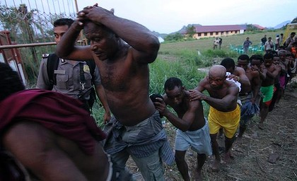
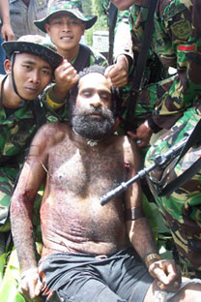
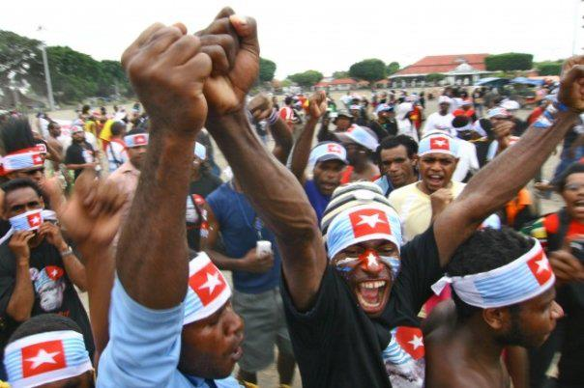
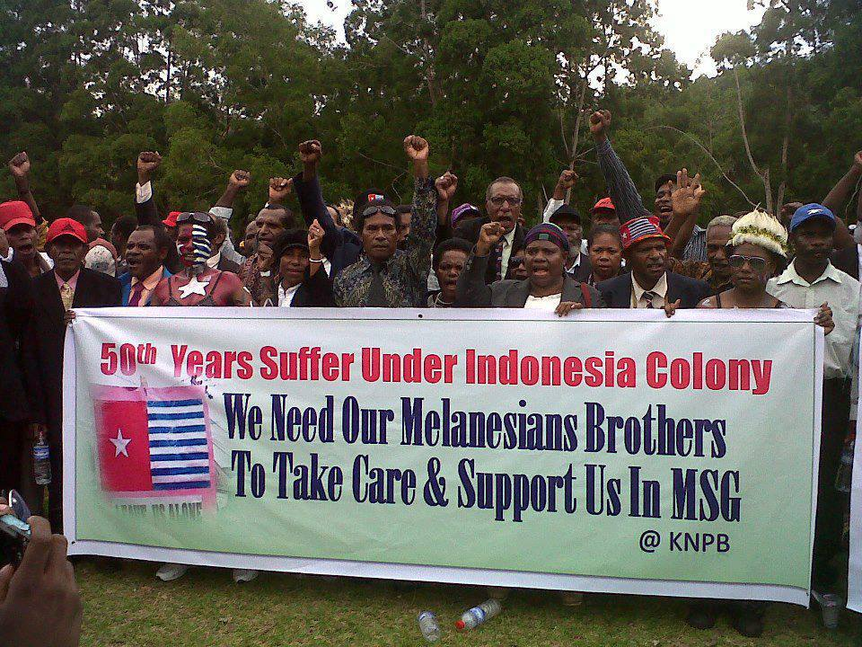
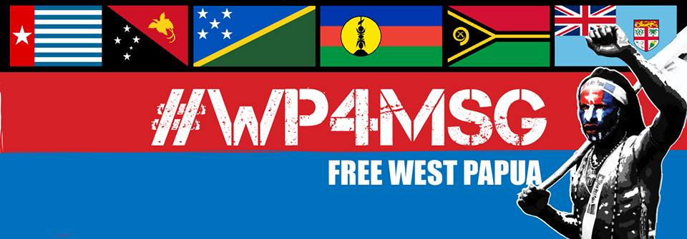
Dear…,
My name is (your name) and you are my parliamentary representative.
I am writing to you as a Melanesian to please show support for our fellow Melanesian brothers and sisters in West Papua.
West Papua is a Melanesian nation bordering Papua New Guinea to the East. In 1961 it was promised independence by its former Dutch colonisers but in 1963 was taken over by Indonesia and in 1969 was illegally annexed during the so called “Act of Free Choice”. This was when Indonesia handpicked just 1,026 West Papuans and forced them at gunpoint to vote in favour of integration with Indonesia.
West Papuans are just as Melanesian as you and I and they never wanted to be part of Indonesia. They are still struggling for their right to self-determination so that they all may freely vote for the freedom of their country. However, the Indonesian government has no respect for our fellow Melanesian people in West Papua and they continue to brutalise and persecute any West Papuans that call for self-determination and freedom.
They continue to murder our people like animals and all the time there is more
evidence of more of our people being killed there by the Indonesian military and police. This is a Melanesian genocide and since 1963, an estimated 500,000 West Papuans have died at the hands of the Indonesian occupying forces, more than 25% of the population.
In January 2015 there were mass arrests and torture of 116 Papuans in the Timika area. Villages were burned down, and some villagers have been shot and tortured. All this has been committed by the Indonesian police and military.
Last month, the Indonesian police opened fire on West Papuans in Yahukimo who were just peacefully fundraising for Vanuatu after Cyclone Pam and killed one. They also tortured and murdered a 17 year old West Papuan boy also in Yahukimo just for peacefully demonstrating for freedom. Even the raising of the West Papuan national flag is prohibited under Indonesian law and Papuans like Filep Karma are imprisoned for 15 years just for raising it.
This is a brutal genocide still being committed against our own people in West Papua and if we let it go on unnoticed, soon there will be no more Melanesians left in West Papua.
But there is hope for our Melanesian brothers and sisters if we act soon. The United Liberation Movement for West Papua (ULMWP) recently submitted an application to join the Melanesian Spearhead Group (MSG). The ULMWP has full support from the government of Vanuatu and the Prime Minister of Papua New Guinea, Peter O’Neill is also showing support for the application.
We need as many politicians and other people as possible to support this application for the MSG to agree on welcoming West Papua back to the Melanesian family. As your constituent I am asking you to also please support our Melanesian brothers and sisters in West Papua to come back to the family by joining the MSG.
Please raise this issue on the floor of parliament and urge the government and all our fellow Melanesians to support our West Papuan people joining the MSG which will be an essential step on their road towards freedom.
As a Melanesian, I feel it is my duty and all our duty to stand up for all Melanesians who are suffering under this genocide terribly. As a fellow Melanesian and as my MP, please join your fellow citizens in supporting the West Papuan people and their struggle against oppression.
Thank you very much
Apartheid in West Papua. Melanesians are rounded up like slaves and tortured in 2011.
West Papuan tribal leader, murdered in 2003 by Indonesian soldiers who held his body up like a trophy photo
West Papuan students protesting for freedom
West Papuans calling for support for MSG membership
I look forward to receiving your reply.
Yours sincerely,
(Your Name)

